Exercise-01: Process ID

File name: “pid.c”
Source code:
#include <stdio.h>
#include <unistd.h>

int main()
{
int pid=getpid();
printf("My Process ID (PID): %d\n", pid);

int ppid=getppid();
printf("Initial Parent PID (PPID): %d\n", ppid);

return 0;
}

Output:
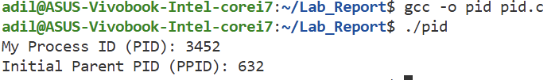

If parent process terminated:
- When I terminate its parent, the child process becomes an Orphan Process.
- If I kill the parent process while the child is still running, the program will not stop running.
- Instead, the output will suddenly change. There can be seen the "Current Parent PID" switch to a new number, typically 1 or the PID of the system manager (like systemd).

Exercise-02: Variable’s Memory Allocation Check

File name: “memory.c”
Source Code:
#include <stdio.h>
#include <stdlib.h>
#include <stdint.h>
#include <math.h>

int global;

void check_memory_segment(int *ptr)
{
uintptr_t target=(uintptr_t)ptr;

int stack=10;
uintptr_t stack_addr=(uintptr_t)&stack;

int *heap=malloc(sizeof(int));
uintptr_t heap_addr=(uintptr_t)heap;

uintptr_t global_addr=(uintptr_t)&global;

double dist_stack=fabs((double)target-(double)stack_addr);
double dist_heap=fabs((double)target-(double)heap_addr);
double dist_global=fabs((double)target-(double)global_addr);

if (dist_stack<dist_heap && dist_stack<dist_global)
{
printf("STACK Segment\n");
}
else if(dist_heap<dist_stack && dist_heap<dist_global)
{
printf("HEAP Segment\n");
}
else
{
printf("GLOBAL Segment\n");
}
}

int main()
{
int var1=64;
static int var2=20;
int *var3=malloc(sizeof(int));

printf("%p in ",&var1);
check_memory_segment(&var1);

printf("%p in ",&var2);
check_memory_segment(&var2);

printf("%p ",&var3);
check_memory_segment(var3);
return 0;
}
Output:
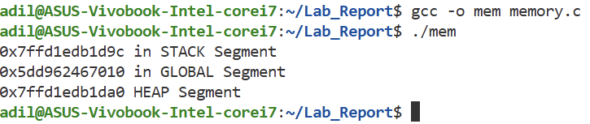

Exercise-03: Command Line Arguments
File name: “cla.c”
Source Code:
#include <stdio.h>
#include <string.h>
#include <stdlib.h>

char to_lower(char c)
{
if(c>='A' && c<='Z')
{
return c+32;
}
return c;
}

int main(int argc, char *argv[])
{
// String Reversing:
int len=(int)strlen(argv[1]);
char str[len+1];
for(int i=0;i<len;i++)
{
str[i]=argv[1][i];
}
str[len]='\0';
char str_rev[len+1];
for(int i=0;i<len;i++)
{
str_rev[len-1-i]=str[i];
}
str_rev[len]='\0';
printf("Reverse of %s is %s\n",str,str_rev);

// Vowel-Consonant Check:
len=(int)strlen(argv[2]);
char str2[len+1];
for(int i=0;i<len;i++)
{
str2[i]=argv[2][i];
}
str2[len]='\0';
int vowel=0;
for(int i=0;i<len;i++)
{
char c=to_lower(str2[i]);
if(c=='a'||c=='e'||c=='i'||c=='o'||c=='u')
{
vowel++;
}
}
printf("%s has %d vowels and %d consonants\n",str2,vowel,len-vowel);

// addition and multiplication
len=(int)strlen(argv[3]);
char str3[len+1];
for(int i=0;i<len;i++)
{
str3[i]=argv[3][i];
}
str3[len]='\0';
len=(int)strlen(argv[4]);
char str4[len+1];
for(int i=0;i<len;i++)
{
str4[i]=argv[4][i];
}
str4[len]='\0';
float a=atof(str3);
float b=atof(str4);
printf("the addition of %.2f and %.2f is %.2f\n",a,b,a+b);
printf("the multiplication of %.2f and %.2f is %.2f\n",a,b,a*b);
}

Output:
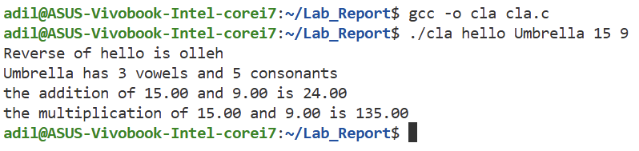
Exercise-04: Working with Fork ()
File name: “fork.c”
Source Code:
#include <stdio.h>
#include <stdlib.h>
#include <unistd.h>
#include <sys/wait.h>

int main() {
char *filename="data.txt";
int pid=fork();

if(pid<0)
{
perror("Fork failed");
return 1;
}

// --- Child Process ---
if(pid==0)
{
printf("Child is Opening file to write...\n");

FILE *fp=fopen(filename,"w");
if (fp==NULL)
{
perror("Child failed to open file");
exit(1);
}

fprintf(fp, "Hello World!! This message was written by the Child Process.");
printf("Child has written the Data. Closing file.\n");

fclose(fp);
exit(0);// Terminate child
}

// --- Parent Process ---
else
{
printf("Parent is Waiting...\n");
// SYNCHRONIZATION: The parent halts here until the child calls exit()
wait(NULL);
printf("Child finished. Parent is Opening file to read...\n");

// Open file in Read mode ("r")
FILE *fp = fopen(filename, "r");
if(fp==NULL)
{
perror("Parent failed to open file");
return 1;
}

char text[100];
// Read the content
if(fgets(text, sizeof(text),fp)!=NULL)
{
printf("Parent is Read from file: \"%s\"\n", text);
}

fclose(fp);
}
return 0;
}

Output:
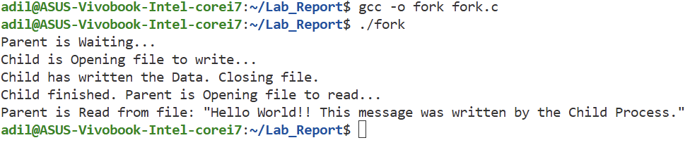

Exercise-05: Semaphore and Race Condition
File name: “sem.c”
Source Code:
#include <stdio.h>
#include <stdlib.h>
#include <unistd.h>
#include <sys/wait.h>
#include <sys/mman.h>
#include <semaphore.h>

#define WITH_LOCK 0
#define PROCESS_COUNT 4
#define LOOPS_PER_CHILD 500

// Define a structure for variables we want to share across processes
typedef struct {
int counter;
sem_t mutex; // Semaphore to act as a lock
} SharedData;

int main()
{
// 1. Create Shared Memory using mmap
// We map a memory block that is readable, writable, and shared between processes
// take different kinds of permission from os
SharedData *shared=mmap(NULL, sizeof(SharedData),
PROT_READ | PROT_WRITE,
MAP_SHARED | MAP_ANONYMOUS, -1, 0);

if(shared==MAP_FAILED)
{
perror("map failed");
exit(1);
}

shared->counter=0;

// Initialize Semaphore:
// 2nd arg (1) = Shared between processes
// 3rd arg (1) = Initial value (unlocked)
if(sem_init(&shared->mutex,1,1)<0)
{
perror("Semaphore init failed");
exit(1);
}
printf("--- Starting Simulation ---\n");
printf("Mode: %s\n", WITH_LOCK ? "SAFE (Locked)" : "UNSAFE (Race Condition)");
printf("Expected Final Count: %d\n", PROCESS_COUNT * LOOPS_PER_CHILD);

// 3. Fork Processes
for(int i=0;i<PROCESS_COUNT;i++)
{
int pid=fork();
if(pid==0)
{
// --- CHILD PROCESS CODE ---
for(int j=0;j<LOOPS_PER_CHILD;j++)
{
// [A] ENTRY SECTION (Lock)
if(WITH_LOCK)
{
sem_wait(&shared->mutex);
}

// [B] CRITICAL SECTION (The Race happens here)
int temp=shared->counter;

// Artificial delay to force context switching
// This makes the race condition happen much more often!
usleep(1);
shared->counter=temp+1;

// [C] EXIT SECTION (Unlock)
if(WITH_LOCK)
{
sem_post(&shared->mutex);
}
}
exit(0); // Child finishes
}
}
// 4. Parent waits for all children
for(int i=0;i<PROCESS_COUNT;i++)
{
wait(NULL);
}
// 5. Results
printf("--- Simulation Finished ---\n");
printf("Final Counter Value: %d\n", shared->counter);

if(shared->counter==PROCESS_COUNT*LOOPS_PER_CHILD)
{
printf("Result: SUCCESS (Data Consistent)\n");
}
else
{
printf("Result: FAILED (Race Condition Detected! Lost %d updates)\n",
(PROCESS_COUNT * LOOPS_PER_CHILD) - shared->counter);
}
// Cleanup
sem_destroy(&shared->mutex);
munmap(shared, sizeof(SharedData));
return 0;
}
Output:
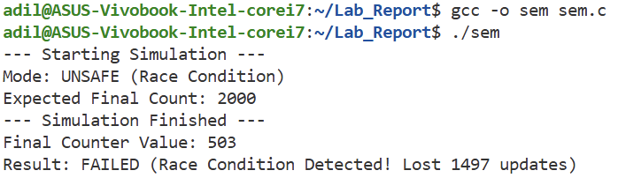
If WITH_LOCK=1:
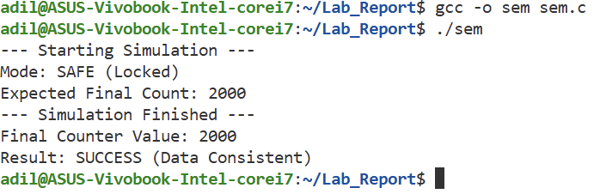

Exercise-06: Child For Each Operation
File name: “opr.c”
Source Code:
#include <stdio.h>
#include <stdlib.h>
#include <unistd.h>
#include <sys/wait.h>

int main()
{
float a,b;
int fd[2];
pipe(fd);
printf("Enter two numbers: ");
scanf("%f%f",&a,&b);
printf("%.2f %.2f\n",a,b);

for(int i=1;i<=2;i++)
{
int pid=fork();
if(pid==0)
{
// child process
// close(fd[0]);
float result;
if(i==1) //addition
{
result=a+b;
}
if(i==2) //subtraction
{
result=a-b;
}
write(fd[1],&result,sizeof(float));
exit(0);
}
else
{
wait(NULL);
float result;
read(fd[0],&result,sizeof(float));
if(i==1)
{
printf("Addition Result: %.2f\n", result);
}
if(i==2)
{
printf("Subtraction Result: %.2f\n", result);
}
}
}
close(fd[0]);
close(fd[1]);
return 0;
}

Output:
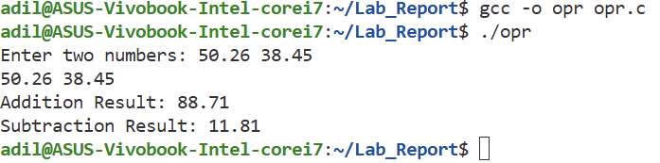

Conclusion:
In this series of experiments, I explored fundamental Operating System concepts and low-level C programming techniques. The tasks progressed from analyzing the memory layout of a single process to managing communication and synchronization between multiple processes. I have learned Memory Layout and Management Through the memory segment identification problem, Command Line Interfaces, Process Creation and Management using the fork () system call, Concurrency and Race Conditions--one of the most critical lessons came from the shared memory counter experiment, Inter-Process Communication (IPC).

